APPENDIX A
Pictorial of the Hydroacoustics Sampling Design
The following is a brief pictorial of the hydroacoustics sampling design that will be used to detect the number of fish entering the intakes at Ralston Afterbay and Middle Fork Interbay. Three split-beam transducers will be ‘fixed’ or attached to the inside of the trash racks of the tunnel intakes at both Ralston Afterbay and Middle Fork Interbay dams. Schematics illustrating the hydroacoustic sampling design are shown in Figures 1 though 4.

To determine the risk of entrainment, the direction that a fish is traveling and its depth location relative to the intakes is assessed. The direction of fish travel within the acoustic beam is translated into a compass angle. Fish that are traveling at angles towards the intake (see example histogram in Figure 5) and are at the depth of the intake are assumed to be entrained (Figure 6).

Figure 1. Picture Illustrating the Hydroacoustic Sampling Design at Ralston - Oxbow Tunnel Inlet Structure.

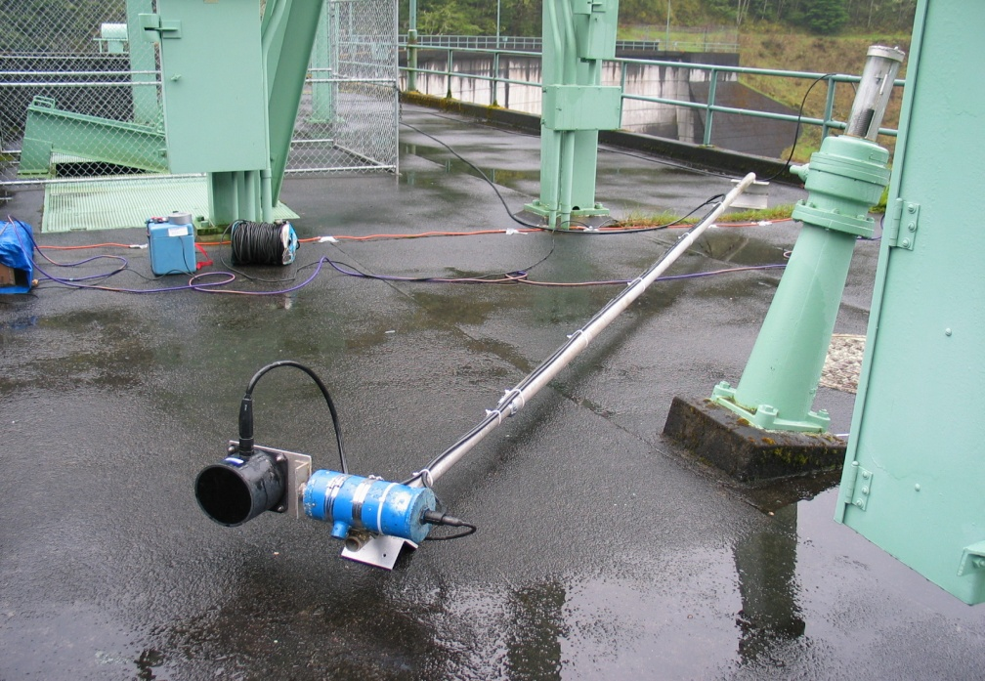
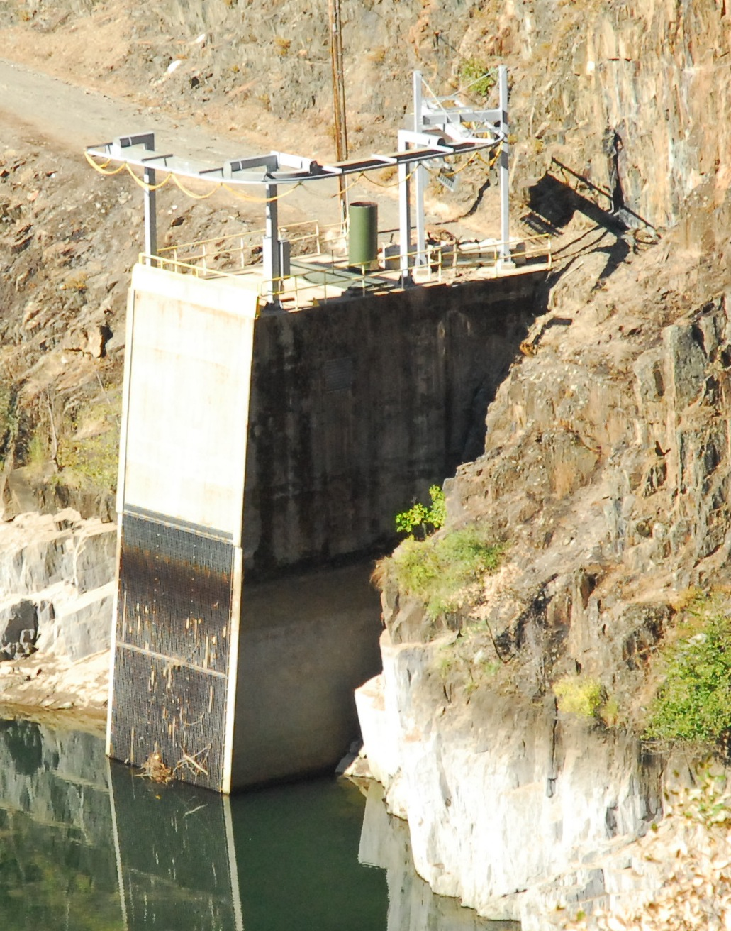
Example of a Transducer
Acoustic Beams Inside Intake Structure
Trash Rack
Transducers
Inside Trash Rack
BioSonics

Figure 2. General Schematic Illustrating the Orientation of Acoustic Beam and Sample Volume at each intake.

Acoustic Beam
Trash Rack
Flow
Intake
Normal Upper Pool Level
Normal Lower Pool Level
Transducer
Intake

Intake Side View Intake Front View

I
Figure 3. Picture showing the Middle Fork - Ralston Tunnel Inlet Structure.

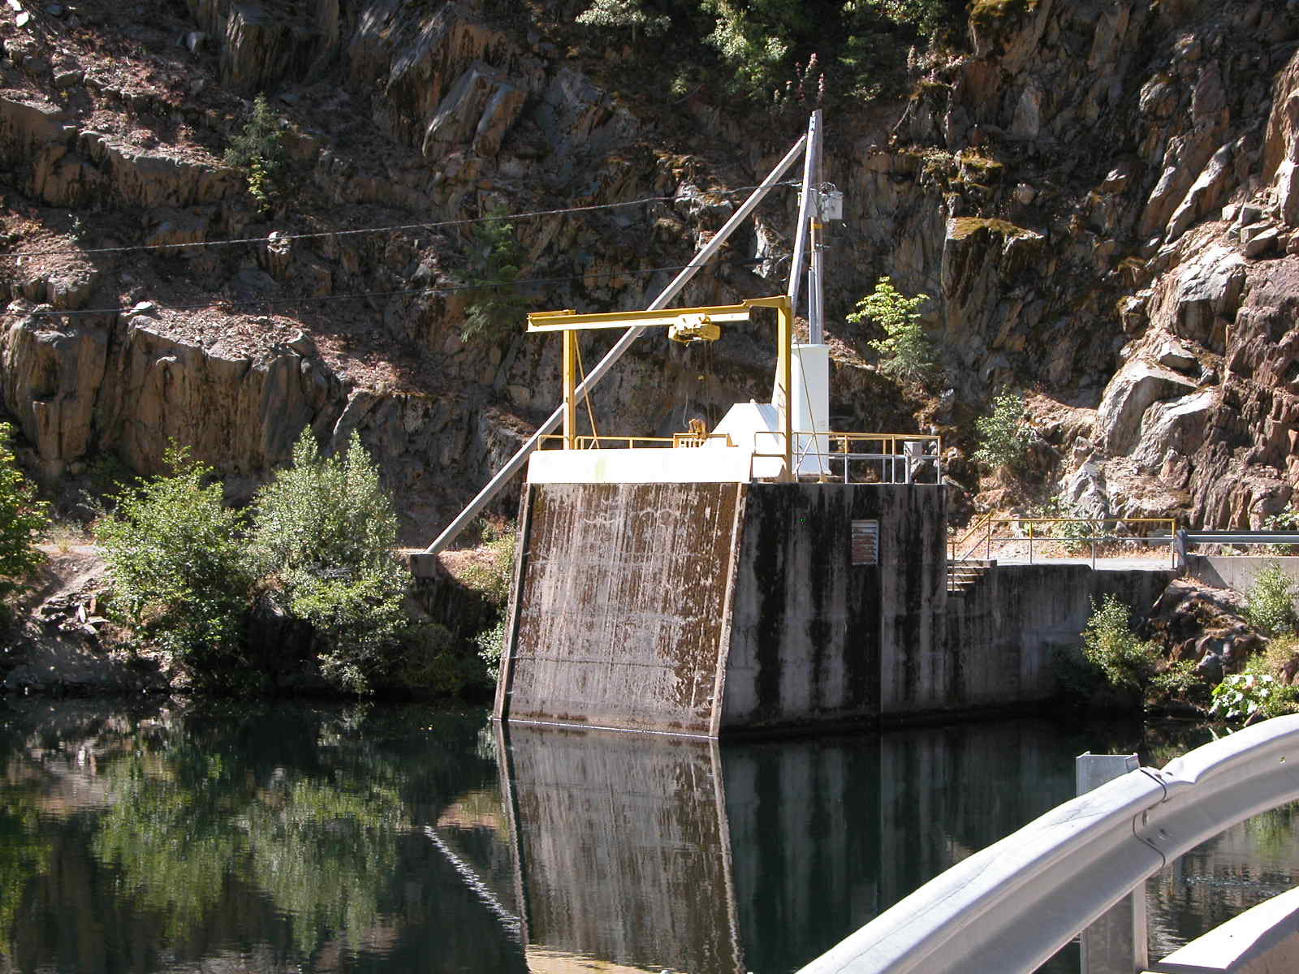
Transducers – mounted on trash racks. Acoustic beams are underwater.

Note: Trash racks are below the water’s surface. Refer to Figure 1 for a similar design at Ralston Afterbay.

Figure 4. Cross-sectional Top View of the Acoustic Beams Showing the Sectors (Blue Color) Where Fish Have a Risk of Entrainment.

Intake
Cross-section of Acoustic Beams
Trash Rack
Flow
45
270
180
225
135
90
0
315

Modified from BioSonics
Figure 5. Example Summary Data of the Number of Fish at Risk of Entrainment Based on the Direction of Fish Travel.
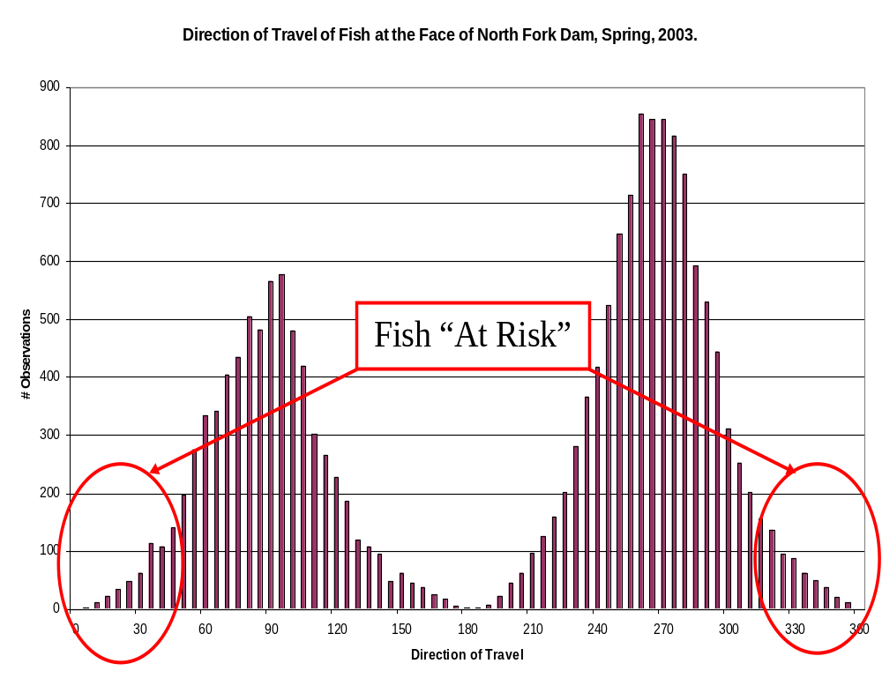

Modified from BioSonics

Figure 6. Assessment of Risk of Entrainment Based on Fish Direction of Travel and Depth.

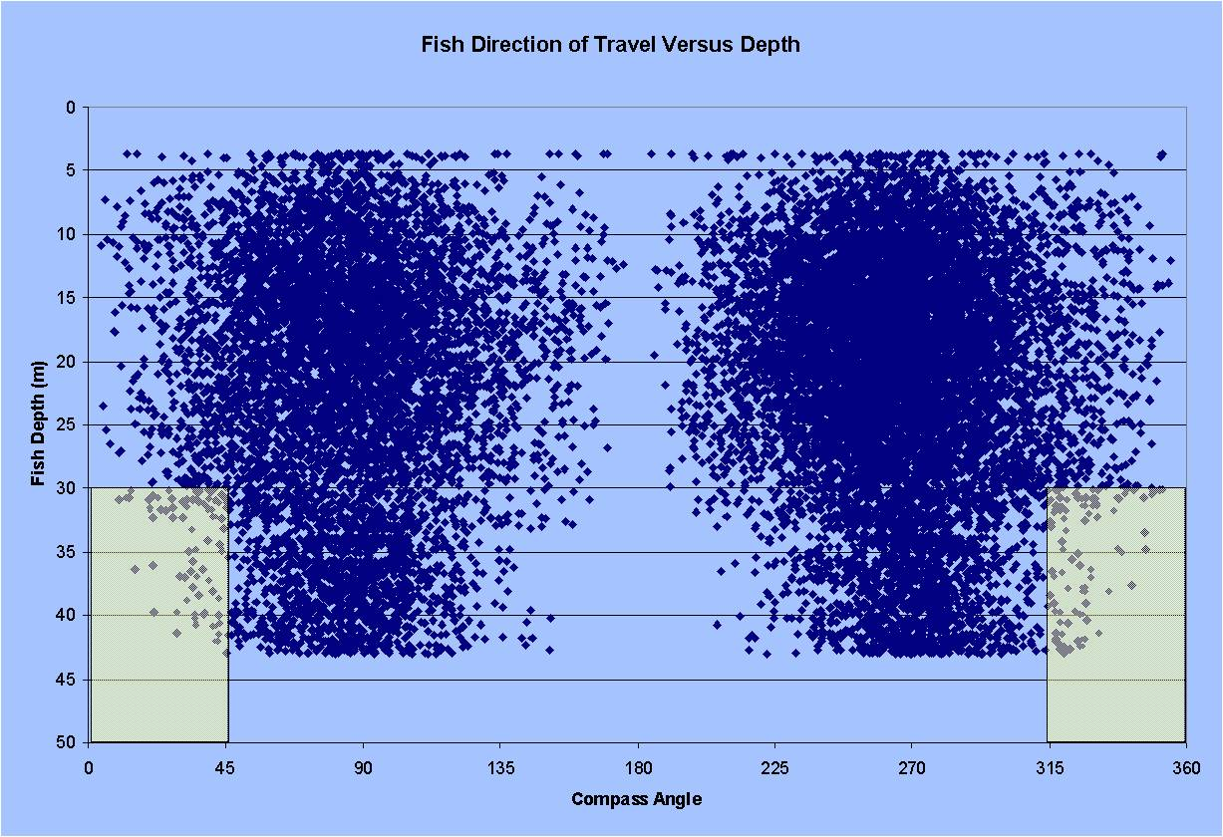
Modified from BioSonics
Hypothetical depth of intake
Number of fish at risk of entrainment

References

BioSonics. 2008. What is hydroacoustics. Available at http://www.biosonicsinc.com/resources/what_is_hydroacoustics.html). Accessed August 2008.

